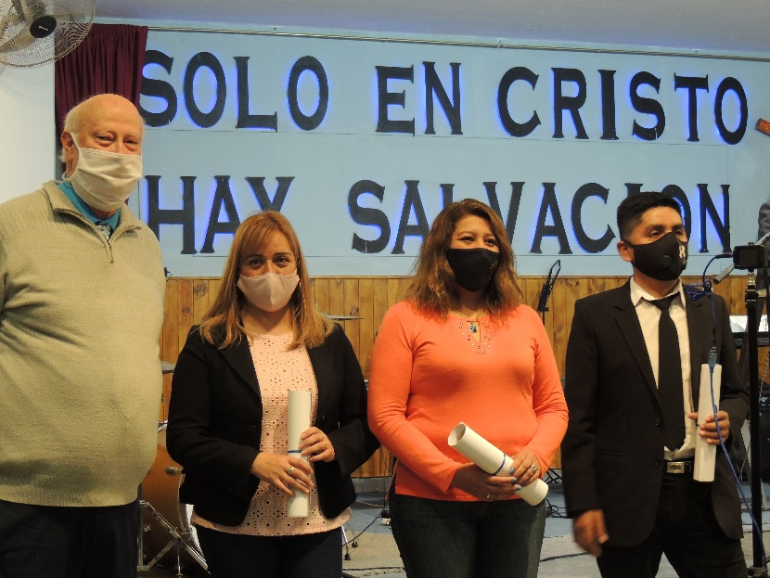

Greetings to all from Argentina:

No, these are not a group of bandits, this is a seminary graduation in a pandemic. This was the first time these students had been together physically in over a year. After at least a full year of virtual classes, it was good to see them. Here’s part of their story from left to right.

Claudia Rivadavia de Cuellar started studying almost 10 years ago. She and her husband were part of a church that ended up turning into a cult. As they sought for biblical answers to their questions, they left the church and started a new work which is growing strong. David, Claudia’s husband, is a new professor at the Seminary. What stands out about Claudia is she had to drop out of classes one year due to her daughter having a bad case of chickenpox. As a result, she had to wait four more years to be able to finish her coursework, but she did it!

Ruth Tapia is a single lady who specializes in primary school education. She is one of the lead instructors in Child Evangelism Fellowship here in NW Argentina. She originally, planned to just take the introductory course, especially the Basic Doctrine class. Four years later, she graduated with one of the highest GPA’s in the Seminary’s history.

Hernán Saldaña comes from a Pentecostal church with a very dominating leader. The teachings he was hearing caused him to question his personal theology and he arrived at the Seminary hoping to find answers. Hernán es a talented teacher (he has over 270 students in the courses he teaches in local schools) and also a gifted musician. His goal after graduating from the Seminary is to be “salt and light” in his local church. He is also discipling his brother in law who is a new student at the Seminary.

Two other students were due to graduate in this group. Carlos Guzmán was unable to get his final projects in on time due to coming down with a severe case of Covid-19. He’s hoping to be part of the graduating class next year. Mabel Chocobar was unable to make the graduation, but merits a special comment. Mabel is from a Free Brethren church. She is a single lady with a very responsible job. Due to work commitments, she was only able to take two elective courses per term. It took her nine years to graduate, but she made it! We’re due to deliver her diploma this week.

Other news

Church is going well, though we’ve had some ups and downs due to restrictions. We’re looking forward to a baptism next month if the authorities will permit it. Several of the girls from the youth group will be baptized plus two men. This will be the largest baptism in the church in years.

The youth group is going well. Jackie has been teaching plastic canvas projects to the girls and now we have a couple of guys who are attending. The Coronado family, seminary students in their second year of study, have decided to join the church. They’re helping with music and the youth and should be a great help in future years.

Medical needs are still a constant. This past week Rod had back to back appointments with several people who needed neurological evaluations. Apart from the treatments, he’s had an opportunity to share some of the Gospel with the neurologist. Today he made contact with a cardiovascular surgeon in an attempt to help the wife of a seminary professor. She has “Chagas” disease which leads to either an enlarged heart or lower intestine without treatment. She hadn’t been able to have a control check-up since March 2020 due to the shutdown of all non-Covid medicine here in Argentina.

Currently the Seminary is on a two-week break which means we’re getting caught up on mission related work. Hopefully Rod will be able to make a trip or two to neighboring provinces to get caught up on some of the housing issues. Eventually he’ll need to go to Buenos Aires, but that is a challenge due to the government management of air travel. They used the pandemic to virtually eliminate all but the national airline for in country flights. Unfortunately, they have more than a 50% cancellation rate of flights which means you can fly to Buenos Aires, but there’s no guarantee when you can get a return flight. There are still hundreds of Argentines trapped outside of the country due to a daily limitation of how many people can arrive at the main international airport. There is hope that this week some of the borders will be opened for people to enter in vehicles from other countries. Our province borders three countries and transportation between Bolivia, Chile, Paraguay and Argentina has been totally shut down for more than a year.

Thanks again for all of your prayer and financial support. We couldn’t minister her in Argentina without your help.

His and yours –

Rod and Jackie Allen
September 10, 2021

